Seth Stapleton Memorial Scholarship Fund
“9th Annual Shoot for Seth”

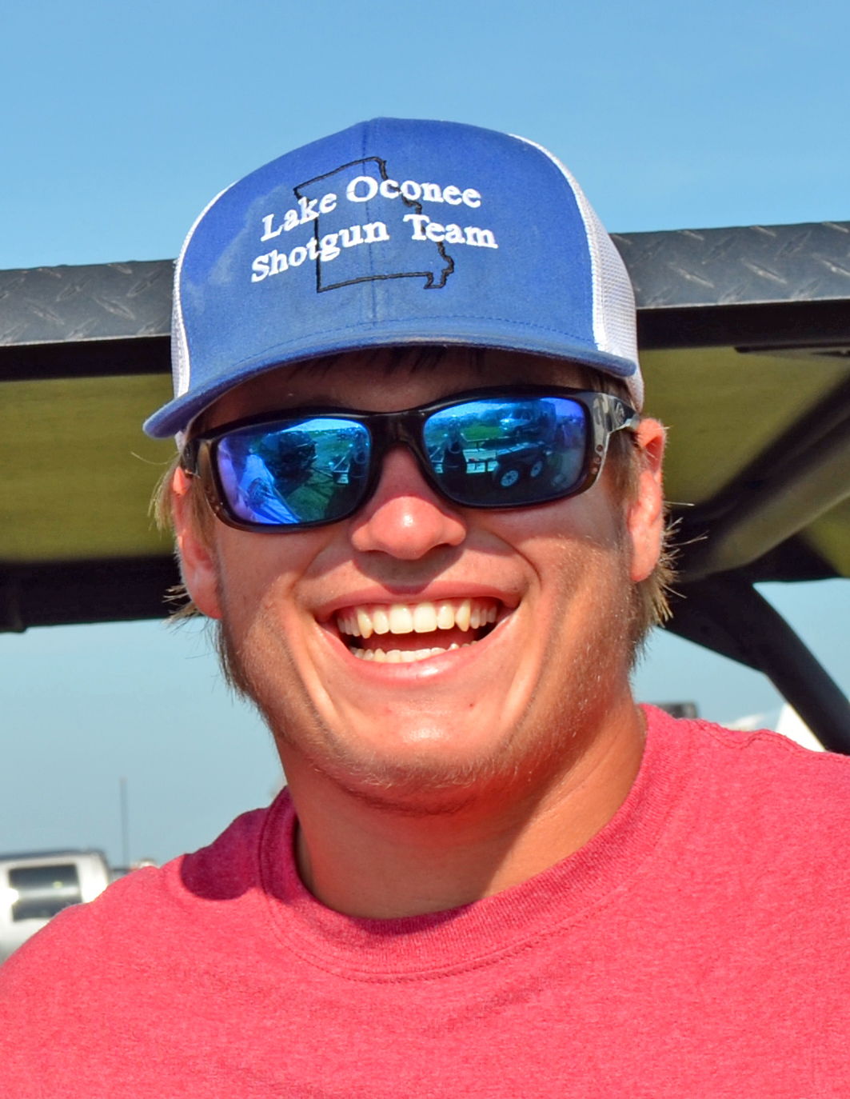

January 15, 2025

Dear Friends,

The time is upon us to start planning the 9th Annual “Shoot for Seth” Sporting Clays tournament. It will be held at Old Hudson Plantation on Saturday,
February 22nd, 2025. The shoot will be hosted by The Stapleton family and The Lake Oconee Shotgun Team.

For those of you who didn’t know Seth, he was a student at Morgan County High School and a member of the Lake Oconee Shotgun Team, who lost his life in a car accident on October 17, 2015. Seth was an extraordinary young man who touched many lives during his short time on Earth. In his honor, the Seth Stapleton Memorial Scholarship Fund was founded. This memorial fund will award scholarships to Morgan County Highschool Seniors as well as Senior (12th grade) shooters who participate in a clay target shooting program through a private or school team in the State of Georgia. In 2024, The Stapleton family awarded 45, $1,000 dollars scholarships to eligible Georgia students, thus bringing the total number of scholarships awarded since the inception of the fund to over 300. Ray and Angela have now given back over $300,000 dollars in Scholarships. None of this would have been possible without God’s blessings and people like you!

Page 2, continued

Our goals for this year are the same as in past years. We are looking for businesses and/or individuals to sponsor and attend this event, as well as make monetary donations and/or donate items for the silent auction. This memorial fund is registered as a Domestic Nonprofit Corporation and is tax deductible.

>Silver Memorial Sponsorship - $300.00 (Includes a sponsor sign with your name and business information.

>Gold Memorial Sponsorship - $450.00 (Includes a station sponsor sign and two shooter entries)

>Platinum Memorial Sponsorship - $650.00 (Includes a station sponsor sign and four shooter entries)

Your sponsorship will buy you and/or your company advertising on our event banner and Station Sponsors will have a custom-made sign displayed at one of the 30 Sporting Clays stations set up on two different courses. Last year’s event brought approximately 450 attendees with over 310 of those shooting in the tournament.

The success of this event depends on the donations and participation from people like you. We cannot thank you enough for taking time out of your day to read this letter and for considering this special organization.

Cordially,

Ray, Angela, Drew, Bridget, and Grayson Stapleton and
Steve and Kristy Lane and The Lake Oconee Shotgun Team

Seth Stapleton Memorial Scholarship Fund
“9th Annual Shoot for Seth”

Sponsorship/Donation Form

_____ Silver Memorial Sponsorship* - $300.00

_____ Gold Memorial Sponsorship* - $450.00
Includes custom sign to be displayed at a sporting clays station and two Shooter entries.

_____ Platinum Memorial Sponsorship* - $650.00
Includes custom sign to be displayed at a sporting
clays station and four Shooter entries.

_____ Donation in the amount of $____________

_____ Item Donation** _________________________

Please pre-register to shoot. Let us know if you prefer to shoot the morning or afternoon rotation. E-mail all shooters names and if any are 18 and under to Steve Lane at shootforseth@gmail.com

*Business cards needed for company information and logo. You can also email your company logo to Steve Lane at shootforseth@gmail.com

Please complete this form and mail it along with your business card and check payable to “Seth Stapleton Memorial Scholarship Fund”. Tax Identification # 81-0870183.

Steve Lane
PO Box 280
Rutledge, GA 30663

All sponsorships and donations must be received by
February 17, 2025

